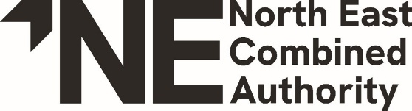
www.northeast-ca.gov.uk
NOTICE

DRAFT STATEMENT OF ACCOUNTS

AUDIT OF ACCOUNTS YEAR ENDED 31 MARCH 2025
LOCAL AUDIT AND ACCOUNTABILITY ACT 2014
ACCOUNTS AND AUDIT REGULATIONS 2015

Notice is hereby given that the publication of the draft Statement of Accounts for the year ended 31 March 2025 for the North East Combined Authority has been delayed.

The reason for delay is that this is the first set of accounts for the North East Combined Authority and more time is needed for appropriate review and quality assurance.

The draft 2024-25 Statement of Accounts are substantially complete and will be published as soon as reasonably practicable, following which the period of public inspection will commence. We expect these accounts to be published no later than 31 July 2025.

