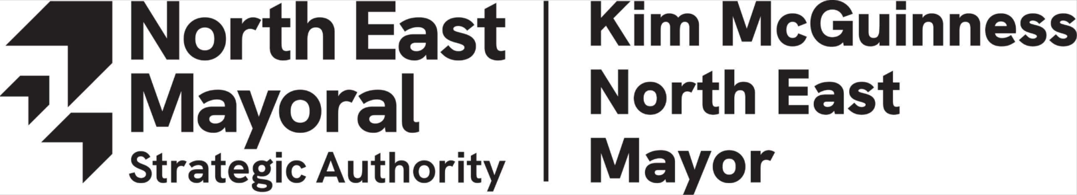

Role Description

Post title | Chair of the North East MSA Business Advisory Council
Grade | Voluntary
Directorate | n/a
Team | n/a
Reporting to | North East Mayor and North East MSA Cabinet

Role Purpose

The North East Mayoral Strategic Authority (‘the MSA’) was formed on 7 May 2024. The North East MSA is led by an Elected Mayor and Cabinet and covers the seven local authority areas of County Durham, Gateshead, Newcastle, North Tyneside, Northumberland, South Tyneside and Sunderland.

The MSA has five key missions, as set out in its Corporate Plan. These are to make the North East:

- The home of real opportunity
- A North East we are proud to call home
- Home to a growing and vibrant economy for all
- Home of the green energy revolution
- A welcoming home to global trade
Strong and lasting partnerships with the private sector will be key to delivering all five of the missions, and the Business Advisory Council therefore has an important role within the MSA’s wider governance structure.

The Business Advisory Council will ensure that the needs and priorities of the private sector are reflected in the MSA’s policymaking, and help to build and maintain positive relationships between the MSA, the private sector and other regional partners. This will enable the region to make the most of the opportunities that exist here and which, if acted on, will deliver positive change for our people.

As independent Chair of the North East MSA’s Business Advisory Council you will lead a group of prominent, diverse and independent business leaders, providing expertise and advice to the North East Mayor and North East MSA Cabinet on the delivery of the Corporate Plan and its missions.

You will represent the business community as an independent and non-voting member of the North East MSA Cabinet, ensuring that the business voice is heard and represented in regional decision making.

Under your leadership the Council will play an active role, supporting and providing advice on the work of portfolios, cross cutting themes and actively championing the North East regionally, nationally and internationally. As Chair you will play a pivotal role in leading the Council’s activity through the development of a delivery plan designed to support and inform the North East MSA’s work programme and decision making.

You will be visible to the business community providing a framework for engaging with business membership organisations, education institutions and key stakeholders on business-related matters.

More specifically you will lead the Council to:

- Help shape the Authority’s thinking on short and long-term issues of importance to businesses and the MSA’s mission to build an inclusive economy that works for all.
- Provide in-depth business input and expertise to strengthen the MSA’s policymaking, support delivery, and secure private sector backing - particularly in relation to the priority sectors identified in the MSA’s Growth Plan.
- Share intelligence which informs the region’s approach to delivering the business facing interventions including business growth, skills and employability programmes, and investments in digital and physical infrastructure.
- Advocate for the region’s interests regionally and nationally, acting in an ambassadorial role on behalf of the MSA, promoting and amplifying messaging around its key priorities, particularly where these relate to specific sectors or the wider business environment.
Time commitment: although the time may vary, we expect that the time required to perform the role of Chair of the Business Advisory Council will be approximately 2 days per month. As this is an unremunerated post the successful applicant will be supported by the North East MSA’s officers to perform the duties outlined.

Duties and responsibilities

Listed below are the responsibilities this role will be primarily responsible for:

- Chairing the North East MSA Business Advisory Council to support the work of the North East MSA and delivery of its strategic objectives.

- Working closely with the North East Mayor, Cabinet, Business Advisory Council and North East MSA executive to create a Council delivery plan.

- Ensuring that the business voice is captured and reflected in the North East MSA’s decision making and delivery programmes.

- Representing the business voice as a nonvoting member of the North East MSA Cabinet.

- Reporting to Cabinet progress against the Council’s delivery plan.

- Guiding Council members to use their regional and national business networks (alongside relationships with government) to champion the North East and the work of the MSA.

- Providing a flexible platform for the development of working groups (as appropriate) with the Mayor and Cabinet in support of key Mayoral and MSA priorities.

- Representing the North East MSA and Business Advisory Council though being an active member of the national Business Board Network.

Person specification

 | Essential | Desirable
Qualifications | - n/a | - n/a
Experience | - Experience chairing a Board of Directors and/or Trustees or leading a voluntary or community organisation.  - A demonstrable passion for the region (this could include experience of leading or supporting business or community projects within the North East).  - Experience of engaging meaningfully with a diverse range of stakeholders. | - Strong and established regional and national business networks that are appropriate to the North East’s strengths, capabilities and opportunities.  - Experience of working with local and national Government to support and influence policy and strategy development.
Skills and Knowledge | - Knowledge of the North East’s strengths, challenges, opportunities and assets.  - Ability to positively promote the MSA’s work.  - Strong negotiation and influencing skills.  - Ability to convene, engage with, and lead a diverse range of stakeholders.  - Political awareness and ability to contribute constructively to nuanced policy discussions.
Personal Qualities | - A belief in inclusive economic growth.  - A collaborative, supportive and constructive approach.  - Action oriented with a desire to deliver activities that will add value.  - Open-minded and future-focused.  - Wants to build relationships across MSAs and strengthen NE influence in national and pan-northern business bodies.  - A strong a desire for the North East to capitalise on devolution.

